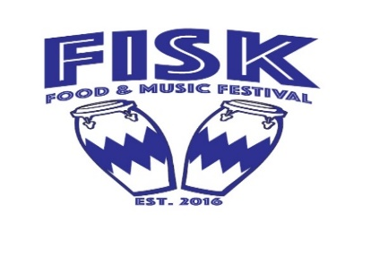
Fisk University Food & Music Festival
Saturday, June 29, 2019
2:00pm – 9:00pm
(Held Rain or Shine, held on Fisk University’s Campus)
Application for Non-Food Commercial & Non-Profit Vendors

Fisk University looks forward to this exciting family-oriented day of food, fellowship, and live music and appreciate your interest in becoming vendor. Vendors will be accepted on a first come, first serve basis. Space for all vendors’ canopies/tents will be 10ft x 10ft, and is not assigned. We will not reserve booth spaces. Booth placement is determined by arrival and set-up time. Set up time begins at 11:00am. You must supply your own table & chairs.
Vendors are expected to place any trash accumulated at your booth in the trash receptacles before you leave for the day. Parking for our non-food vendors is behind Talley Brady Hall and the Van Vechten Art Gallery. The entrance to the parking lots is on D.B. Todd Blvd.
The booth fee for churches and non-profit organizations is $75 and commercial vendors will be booth fee is $125. Please complete the attached application and return with fee by Monday, June 17, 2019.

Please mail or bring your check and/or money order made payable to:
FISK UNIVERSITY
ATTN: Sharon Kay, Food and Music Festival Chair
1000 17th Avenue North
Nashville, TN 37208

For more information, please contact Sharon Kay at (615) 329.8754 or by e-mail skay@fisk.edu

Fisk University Food and Music Festival
Non-Profit & Non-Food Commercial Vendor Registration Form
Saturday, June 29, 2019 (Rain or Shine, held on Fisk University’s Campus)

Vendor Name: ______________________________________________- ___
Owner/Contact: ________________________________________________
Address: _______________________________________
City: _______________________ State:__________ Zip: ________
E-mail: __________________________________________
Phone(s): __________________

Please give a description of your products and/or what will be in your booth.
______________________________________________________________ __ ________________________________________________________________________________________________________________________________________________ _____

Please sign to acknowledge that you have read all of the information, rules and regulations.

Signed: ______________________________ Date: ___________
================================================================
Application is not complete without:

Signed Application
Booth Fees: $75.00 Non-Profit Organization; $125.00 Commercial Vendors

Please send your check and/or money order payable to:
FISK UNIVERSITY
ATTN: Sharon Kay, Food and Music Festival
1000 17th Avenue North
Nashville, TN 37208

